*Application metrics are a numerical representation of data that determines the current state of the service or component. It provides a holistic view of the system’s health and performance.*

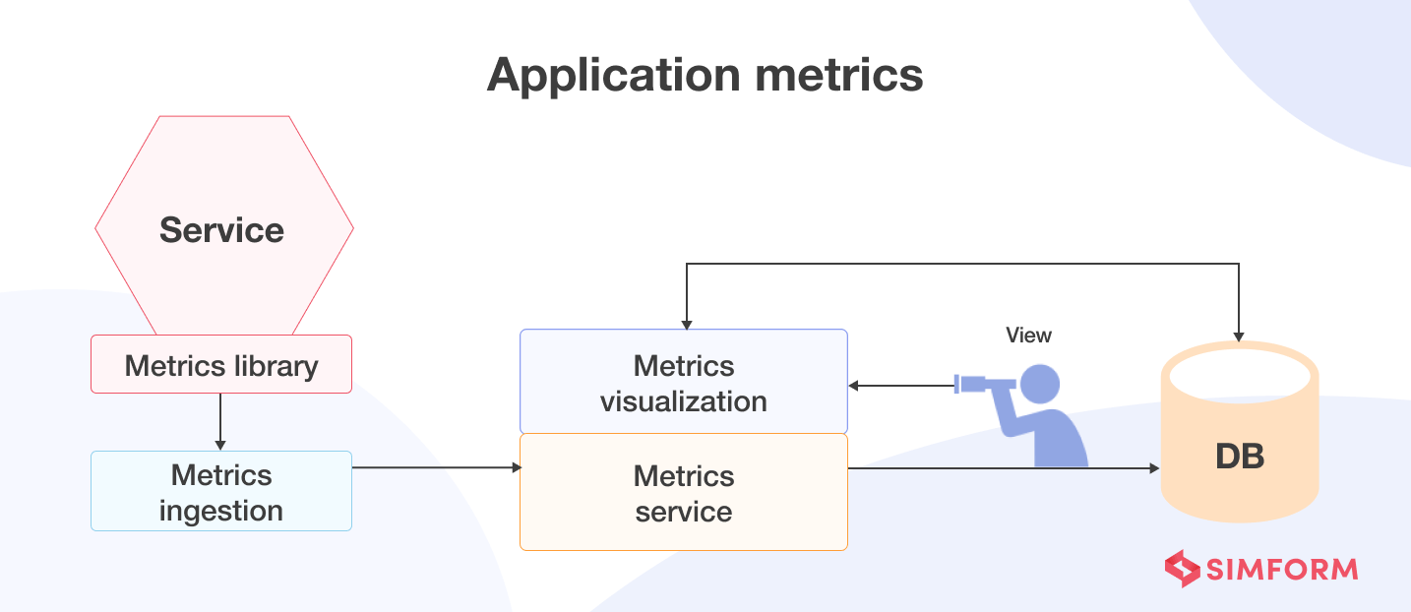

*Some of the common application metrics are:*

* ***Infrastructure-level metrics:****such as CPU, memory, and disk utilization*
* ***Application-level metrics:****such as service request latency and several requests*
* ***End-user metrics:****such as application load times*

***How do application metrics facilitate observability?***

*In a microservices-based application, gathering application metrics is the responsibility of developers. But, first, they need to set up instrumentation for various services to collect the required data that exposes the system’s health and performance.*

*There are two models for aggregating metrics from a service:*

* ***Push:****The service pushes metrics to the metrics service*
* ***Pull:****The metrics services pull metrics from the service*

*With the help of accurate metrics derived from either of these methods, developers or the SRE team can observe the IT system and fine-tune it for better performance.*